

Year 12 ATAR Physics

Unit 3 Semester 1 2023

**Electromagnetism Test**

Student Name: ______________________________

Assessment Date:

**TOTAL MARKS**

**/60**

Working time: 55 minutes

Weighting: 5%

Teacher Comments:

**You should answer ALL of the questions and show full working.**

**Express all numerical answers to three (3) significant figures unless it is an estimate or otherwise requested.**

**Question 1 (3 marks)**

For each of the following, describe the force acting on the wire as either *up, down, left, right, into page, out of the page or no force*.

|  |  |
| --- | --- |
|  | **Force** |
|  |  |
| [Image result for magnetic field out of page](https://www.google.com.au/url?sa=i&source=images&cd=&cad=rja&uact=8&ved=2ahUKEwjkyL6K1qzbAhXIVbwKHbJRABcQjRx6BAgBEAU&url=http://lrrpublic.cli.det.nsw.edu.au/lrrSecure/Sites/LRRView/13936/13936_03.htm&psig=AOvVaw0pIg1k-aU19-fq8V_CLylx&ust=1527743471934386)  **** |  |
| ****  N  S  N  S |  |

**Question 2 (3 marks)**

A current of 5.00 A flows in a wire that is placed in a magnetic field of 0.50 T. The wire is 0.70m long and is at an angle of 60o to the field.

1. Calculate the magnitude of the force on the wire. [2]
2. State the direction of the force on the wire. [1]

**Question 3 (7 marks)**

Two 5.00 m long parallel wires are separated by 0.20 m. Both wires have a current of 3.25 A flowing. The currents in the wires flow in opposite directions.

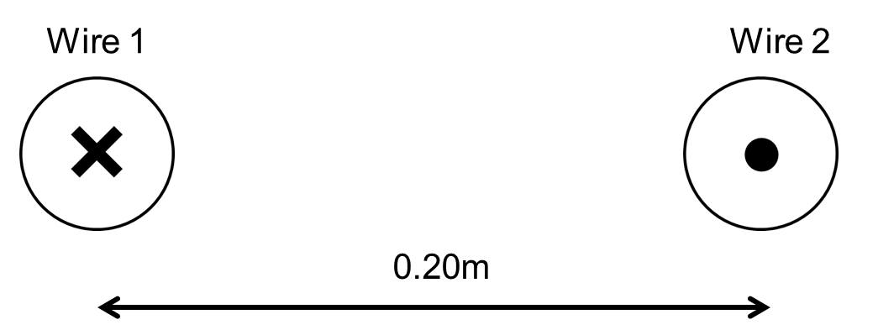

1. Draw the magnetic field produced by the current flowing in Wire 2. Include at least 3 field lines. [2]
2. Will the wires experience attraction, repulsion or no force while the currents are flowing?

Circle one option below. [1]

*Attraction Repulsion No force*

1. Calculate the magnetic flux density at Wire 1 due to the current flowing in Wire 2. [2]
2. Calculate the magnitude of the force applied to Wire 1 due to the current flowing Wire 2. [2]

**Question 4 (4 marks)**

A small magnet is moved towards a long solenoid as shown in the diagram below. The solenoid consists of 20 coils, each with an area of 1.23 x 10-3 m2.

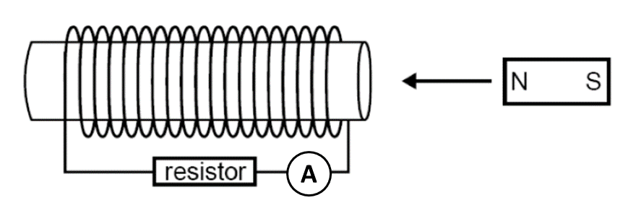

1. Draw the direction of the induced current through the resistor as the magnet is moved towards the solenoid. [1]
2. As the magnet approaches the solenoid, the magnetic field through the solenoid increases from 0.01 T to 0.04 T in 0.20 seconds. Calculate the magnitude of the induced emf in the solenoid. [2]
3. The magnet is moved at a constant velocity through the solenoid until it leaves out the other side. Which graph best represents the ammeter readings over this time? [1]

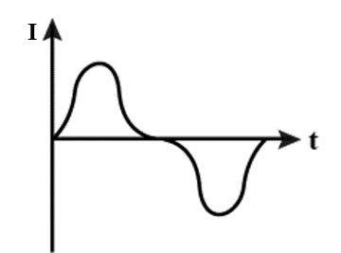

1. ii)

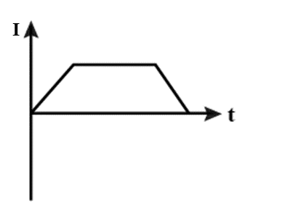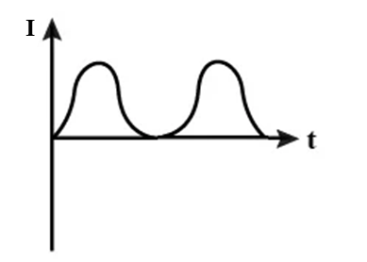

iii) iv)

**Question 5 (4 marks)**

Two small electrically charged spheres are hanging from the ceiling by non-conductive wires. Each sphere has a mass of 0.50 kg. The distance between the spheres is 4.00 cm. The charge of sphere P is -1.00 µC and the charge of sphere Q is +1.00 µC.

Calculate the angle θ that the wire supporting sphere P makes with the horizontal.

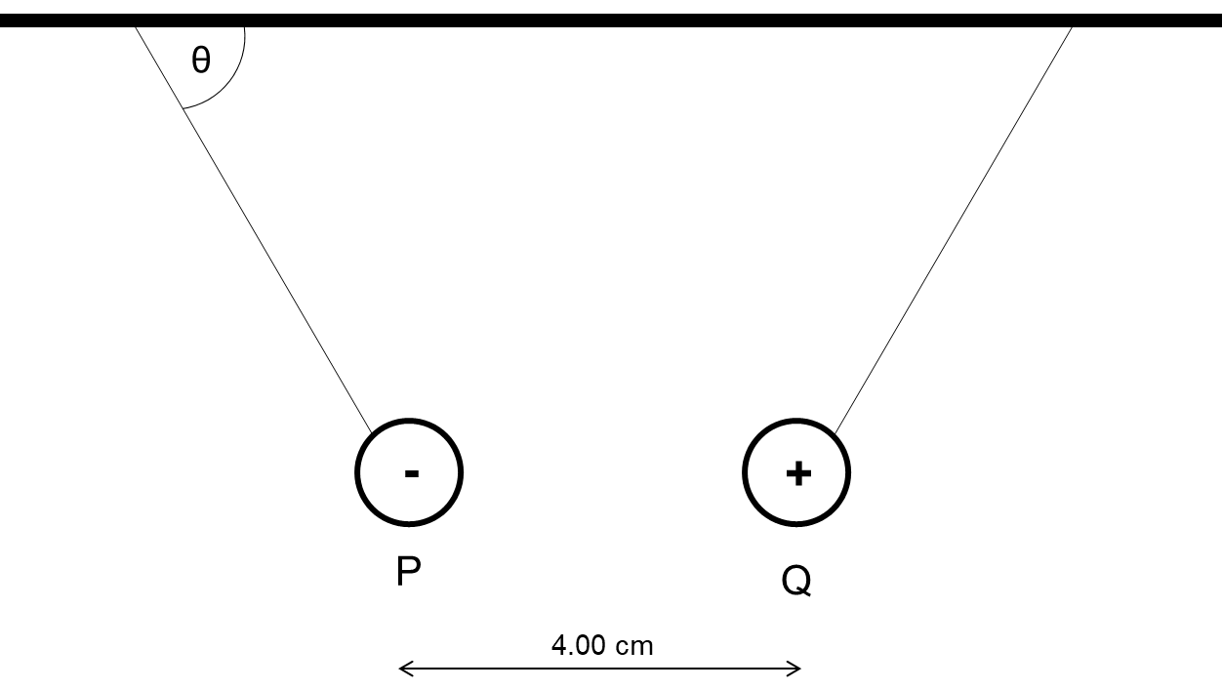

**Question 6 (11 marks)**

The DC motor below consists of a rectangular coil with a length of 55.0mm and a width of 35.0mm and 25 turns. A current of 2.20 A is passed through the coil. The magnets produce a magnetic field of 9.08 mT.

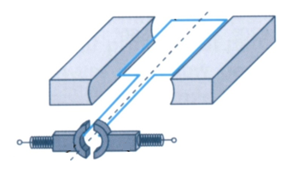

Part A

1. Calculate the magnitude of the maximum torque produced by the motor. [3]
2. What is the name and the purpose of the ‘Part A’ as shown on the diagram. [2]
3. Complete the graph below to show how the torque varies as the motor is rotated 360o, starting at horizontal. [3]

𝜏

0° 90° 180° 270° 360°

1. State three ways that the torque of the motor can be increased. [3]

1.

2.

3.

**Question 7 (11 marks)**

Nitrogen-14 ions (N3-) of mass 2.33 x 10-26 kg and triple negative charge are accelerated from rest using the potential difference established between two parallel plates. The plates have a potential difference of 5000 V across of gap of 8.00 cm. Ignore the effects of gravity and air resistance for this question.

1. Calculate the electric field strength between the parallel plates. [2]
2. Calculate the magnitude of the electric force acting on the nitrogen ions. [2]
3. Calculate the maximum speed reached by the nitrogen ions as leave through the small slit in the parallel plates. [3]

When the nitrogen ions leave the parallel plates, they are fed into a uniform magnetic field within a mass spectrometer. The magnetic field has a uniform flux density of 123 mT. The setup and the direction of the magnetic field is shown below.

If you did not calculate a value for (c), use 5.00 x 105 ms-1.

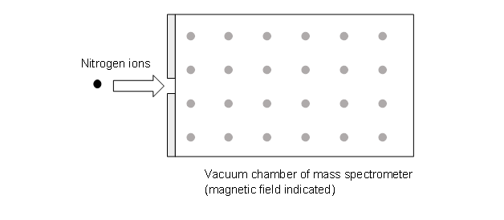

1. Draw an arrow on the diagram above to show the general direction that the nitrogen ions would follow. [1]
2. The force acting on the nitrogen ion due to the magnetic field will cause it to follow a circular path. By equating the magnetic force and the centripetal force, derive an expression to calculate the radius of the path taken by the nitrogen ion and evaluate the radius. [3]

**Question 8 (9 marks)**

A search coil is a specialised device that can be used to experimentally determine the magnetic flux density of a magnet. It consists of a very small, tightly wound coil attached to a voltmeter or oscilloscope. The search coil is moved inside the magnetic field and the induced emf is recorded.

A circular search coil of 5000 turns with a radius of 10.0 mm is used to determine the magnetic flux density of a large horseshoe magnet. The magnet has a uniform flux density between the two poles.

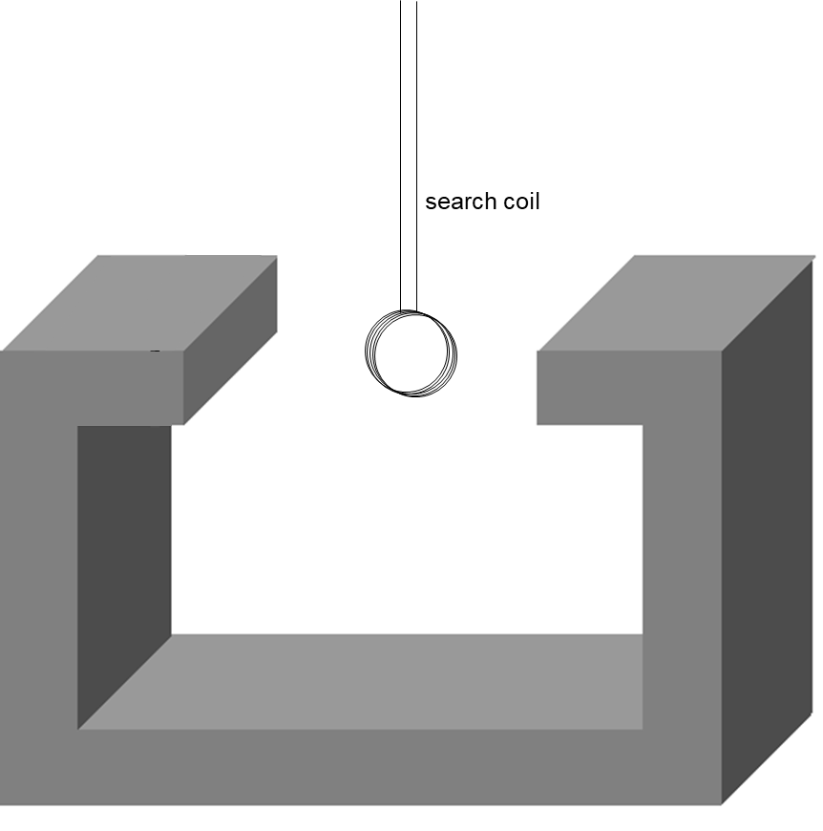

1. The search coil is orientated such that the magnetic flux through the coil is maximised. The coil is then rotated at a constant speed. It rotates 180o in 0.10 s and a peak voltage of 16.7 V is recorded.

Calculate the magnetic flux density of the magnet. [3]

1. Complete the graphs below to show the magnetic flux and the recorded emf as the search coil undergoes one full rotation, starting at maximum flux. [6]

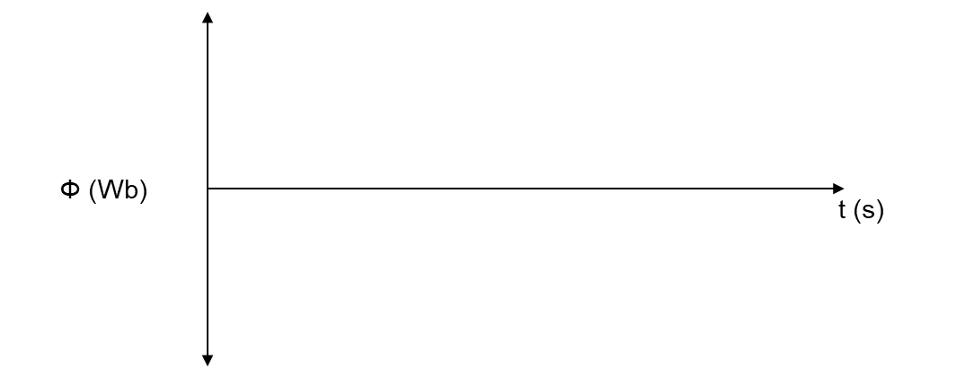

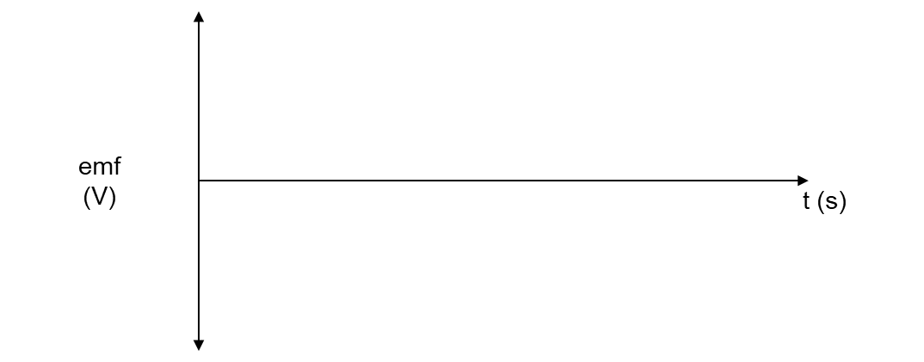

**Question 9 (8 marks)**

An aeroplane with a 15.0 m wingspan is flying North to South over the equator when it is instructed to change course to due East. It does this by executing a quarter-circle turn of radius 37.0 m. The Earth’s magnetic field at this location has a strength of 5.00 x 10-5 T.

The potential difference between the wingtips is measured as the plane executes the 90o turn and show in table and graph below.

|  |  |
| --- | --- |
| sin θ | ε (x10-3 volts) |
| 0 | 0 |
| 0.2 | 3.10 |
| 0.4 | 5.40 |
| 0.6 | 8.65 |
| 0.8 | 10.9 |
| 1 | 14.4 |

1. Calculate the gradient of the line of best fit, showing all working. [3]
2. Estimate the time taken for the plane to complete its turn. [5]

**END OF TEST**